Unit:7
Teacher’s name: | Abdikhanieva M
Date:13.04.2022
Grade: 2 g | Number present: 20 absent:
Theme of the lesson: | What animals can?
Learning objectives(s) that this lesson is contributing to: | 2.L4 recognise with support short basic questions relating to features such as colour and number  2.UE13 use can to talk about ability and to make requests and offers; use can / can’t to talk about permission  2.UE17 use me, too to give short answers
Lesson objectives: | All learners will be able to: remember the content and use the main information in tasks  Most learners will be able to: define the topical words to complete the sentences  Some learners will be able to: analyze the content and express their meanings.
Assessment criteria | -match the pictures and topical words correctly  -answer the questions correctly
Value links | Ls will work respecting each other during the session
Cross curricular links | Early Literature
ICT skills | Using videos & pictures, working with groups
Previous learning | Ss read the Stonehenge story and recognize the usage of topical words

Part of the lesson/Time | Teacher’s activity | Student’s activity | Assessment | Resources
Beginning of the lesson  Warming-up  5 мин. | Organization moment :  1.Greeting. sing the song «Hello»  2. Organization moment.  David the three group from future energy  Ask home task. Count to twenty  Warm up activity.  Ss listen to the sounds and guess the animals. Setting the aims.  T shows the pictures of animals, verbs of actions and Ls are asked to guess the topic of the lesson. | Ss define the sounds of animals correctly and say the name of animal in chorally.  The aim: develop listening skills and critical thinking skills. And review the previous words.  Efficiency:learn to predict the theme of the lesson. | From the beginning of the lesson to motivate Ss T uses  “Smiles” method to evaluate. |   Animal video picture
Pre-learning  10 min.  Individual work. | Do the exercise 1 in the poster individually. Look at the picture read the animals name and match  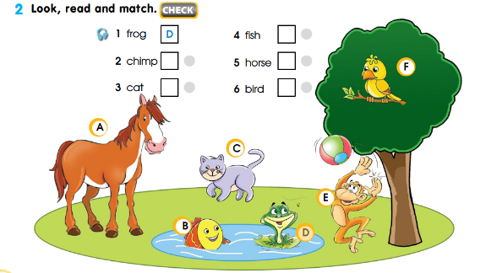  Exercise 2  Match the verbs with animals picture  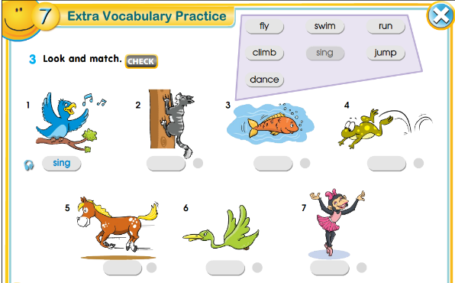  Modal verb CAN\CAN’T  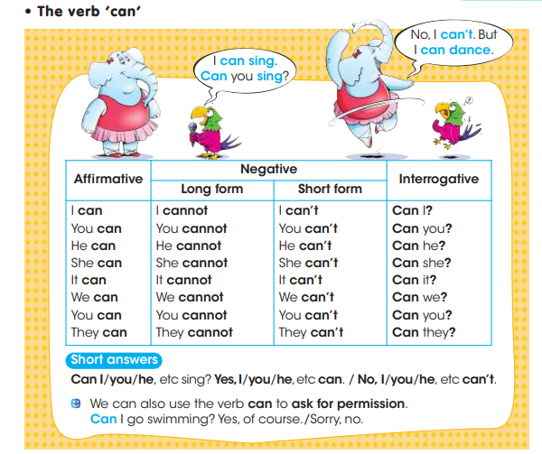 | Ss responding the new words and match  Make the sentence modal verbs and give examples to the teacher. And answer the questions of teacher.  Aim: develop Ss grammar literacy and practice to review the use of grammar.  Efficiency: develop vocabulary making some long sentences. | Encourage Ss T uses  Feedback: “Hamburg” method:  Excellent! You do it, but pay attention to the spelling of the words. | Poster  Worksheet on Whiteboard
Middle of the lesson  Individual work.  15 min. | Pre-listening activity.  T elicits what animals can do.  While listening activity. Learners watch the video and say which animal can do any actions.  (Differentiation by task)  Checking comprehension: Teacher asks yes\no questions. Teacher suggests students to clap their hands for “yes” and blink their eyes for “no”.  Will you sing a song?  Will watch a video?  Will you say the animal actions. 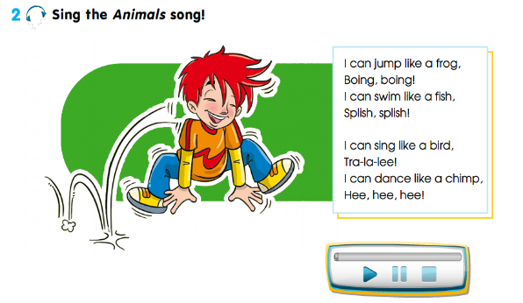  Checking comprehension: Teacher reads yes\no statements and asks students to put their thumbs up for “yes”  and their thumbs down for “no”.  - You work individually.  - You write the sentences.  Learners present their works.  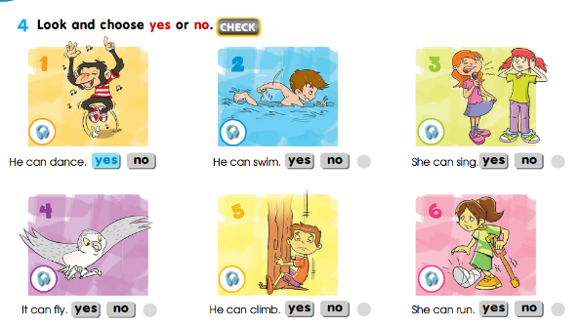  (I) Post –listening activity.  T provides student with handouts and pictures of animals. Learners think and say them in the appropriate column.  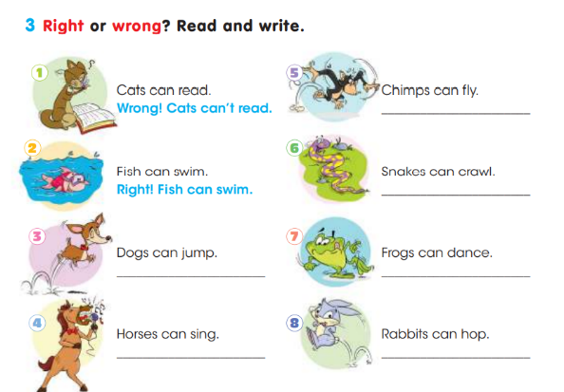  Example:  Q: cats can read A: wrong, cats can’t | Ss watch the video and say the animal actions orally. And answer the questions clapping their hands and blinking their eyes. And complete the table according to the actions of animals.  Aim: practice the grammar in their speech and express clearly.  Efficiency: make them think critically and learn to listen to each other.  Differentiation: this task helps more able students to use the grammar in their speech constructively and less able students use the grammar looking at the video and animal actions.  Aim: reuse the key words and increase their vocabulary skills.  Efficiency: reflect their knowledge repeating and using the topical words again.  Differentiation: this task helps more able students to use the grammar in their speech constructively and less able students use the grammar looking at the video and animal actions. | Descriptor A learner  -makes words with mixed letters  -reads the words  -makes short simple sentences  Teacher-based assessment. Teacher provides feedback to Ss.  Teacher-based assessment. Teacher provides feedback to Ss. | Worksheet on  Whiteboard  https://youtu.be/uhW1-YW73Dk  https://youtu.be/t99ULJjCsaM  https://youtu.be/30ePPeUbwSs
Individual work.  10 min. | Look at the pictures and do crosswords pazzle. Say what animals can do. Tell what you can see the picrure. Example:  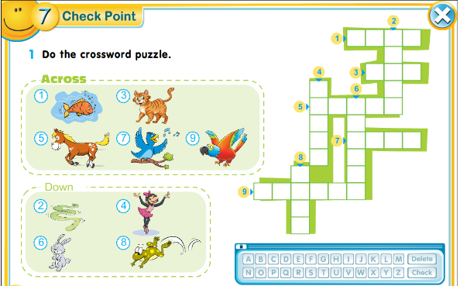  Exersice:3 p 98  Show the story about drum. And give the home work  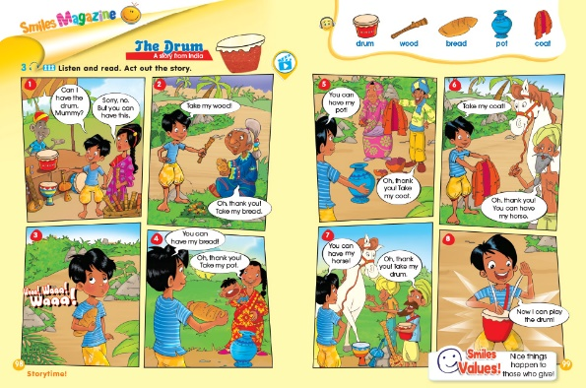 | After the video Ss use the actions of animals in their dialogue.  Differentiation:«Making a dialogue» method less able Ss use teacher’s samples and more able Ss express their thoughts intelligibly. | Descriptor A learner  • asks and answers the questions;  • says what animals do in the picture;  • says what he/ she can do using me, too;  • pronounces the words and expressions properly.  Total: 1point  Feedback:  “Thumbs up,  Thumbs down” | Worksheet on  Whiteboard
End of the lesson.  Reflection  Individual work:  5 min. | Teacher gives feedback to Ss. 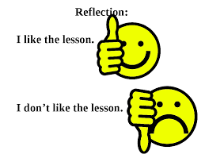This might be done in oral form.  Learners reflect on their learning:  What has been learned  What remained unclear  What is necessary to work on | Ss answer the questions of the teacher and some of them say clearly about their understanding of the lesson.  Aim:make them to say a short sentences and develop their speaking skills.  Efficiency:activate Ss to give answer. | Teacher-based assessment. Teacher provides feedback to Ss. | Whiteboard  Written the questions

